Name:Prithika BH
Reg no:19242403
MySQL Activity

CREATE TABLE
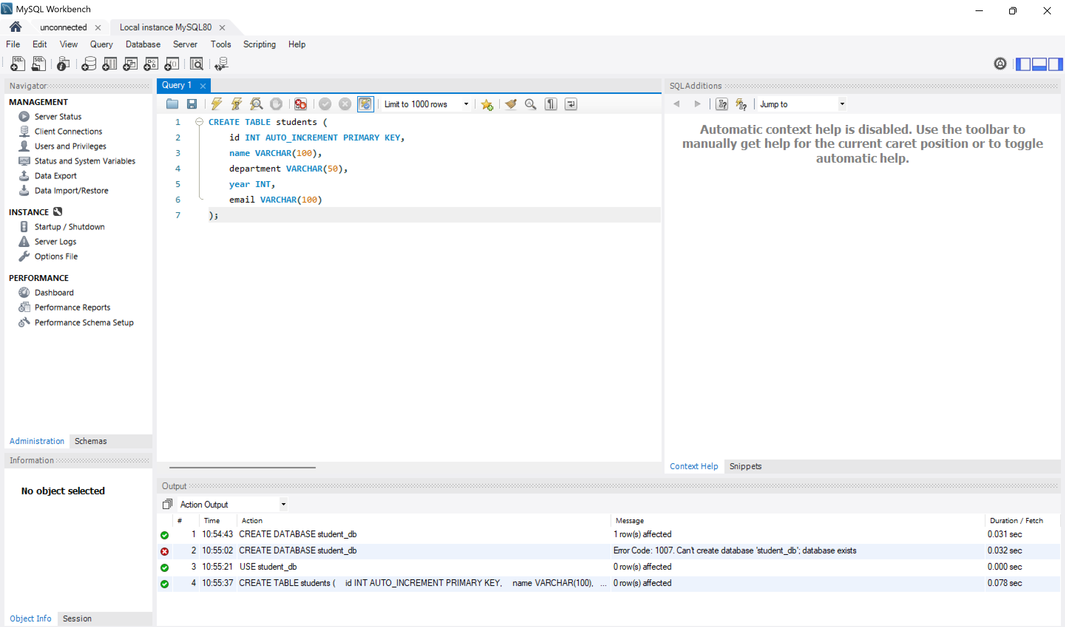

INSERT
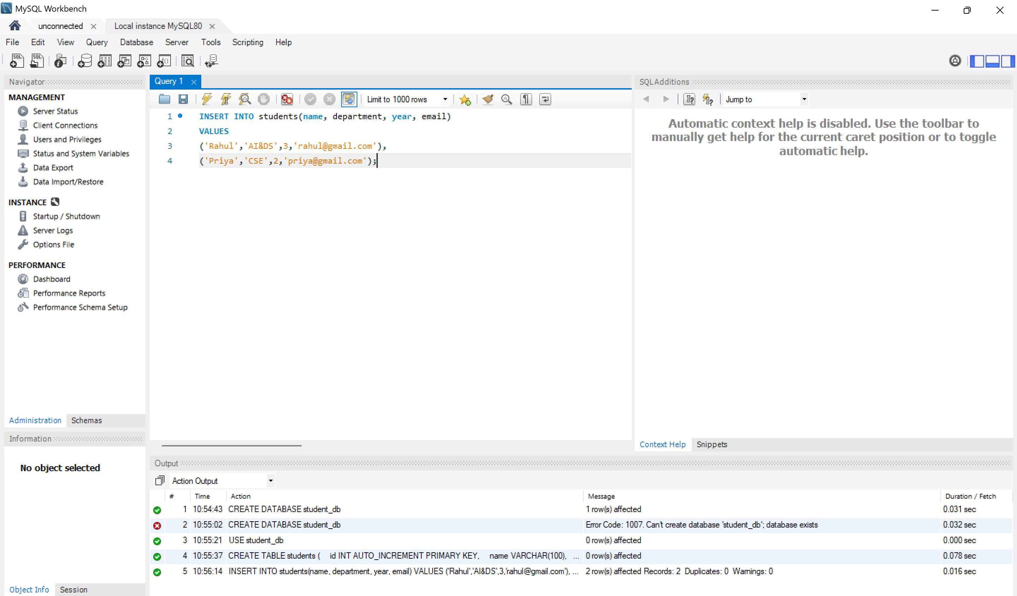

SELECT
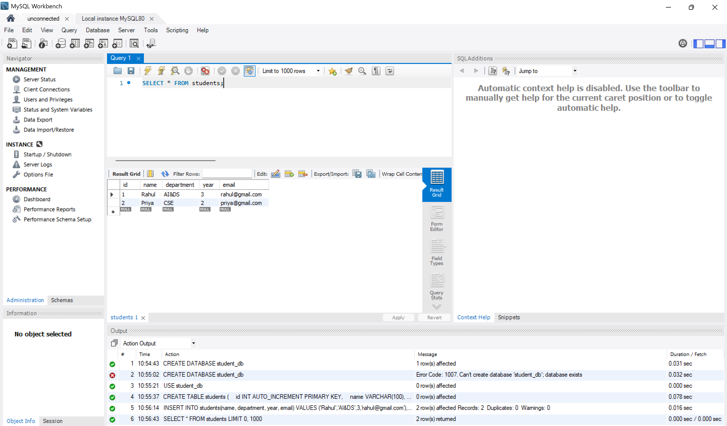
UPDATE
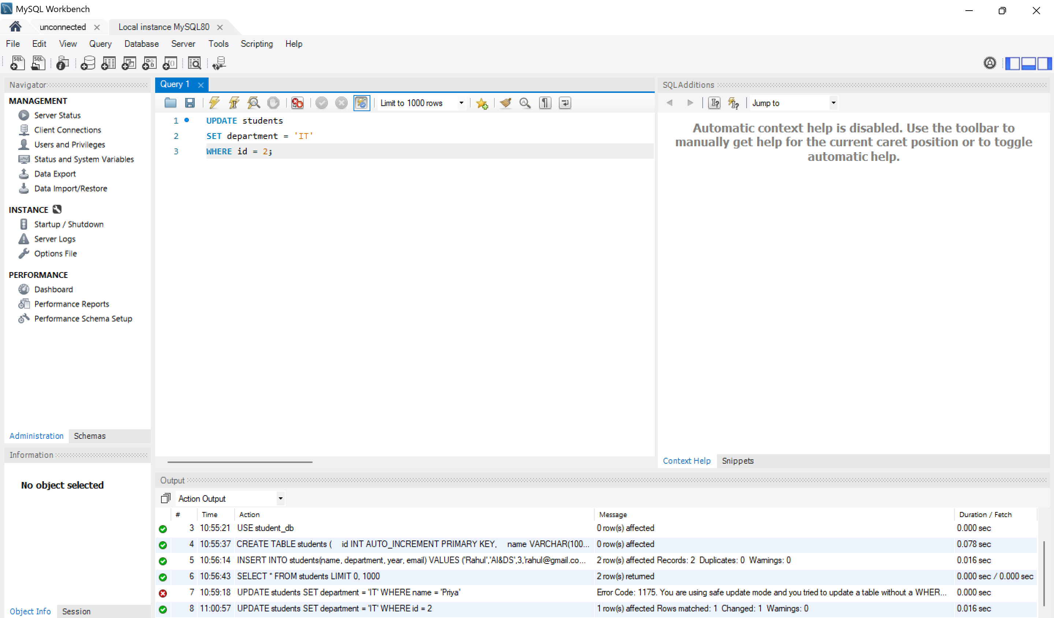

DELETE
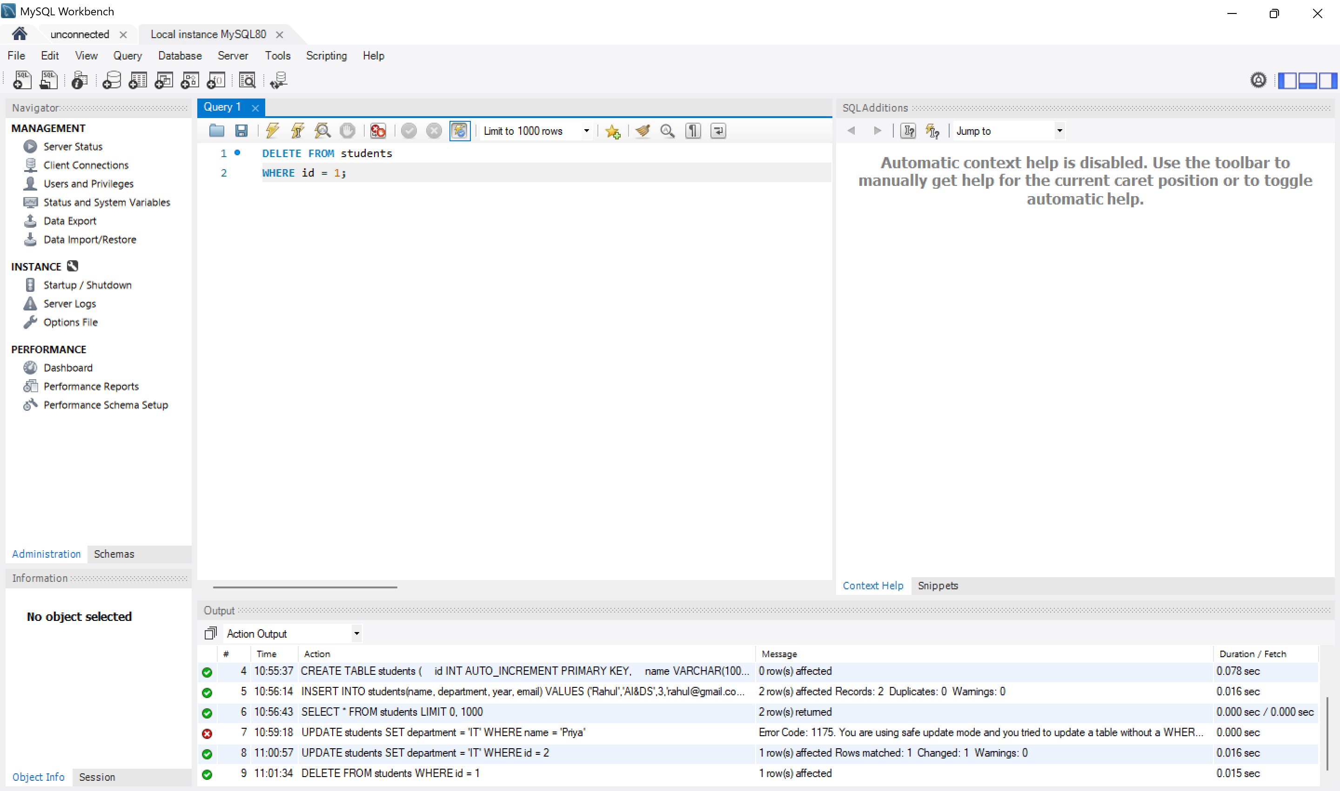
Basic WEB APP
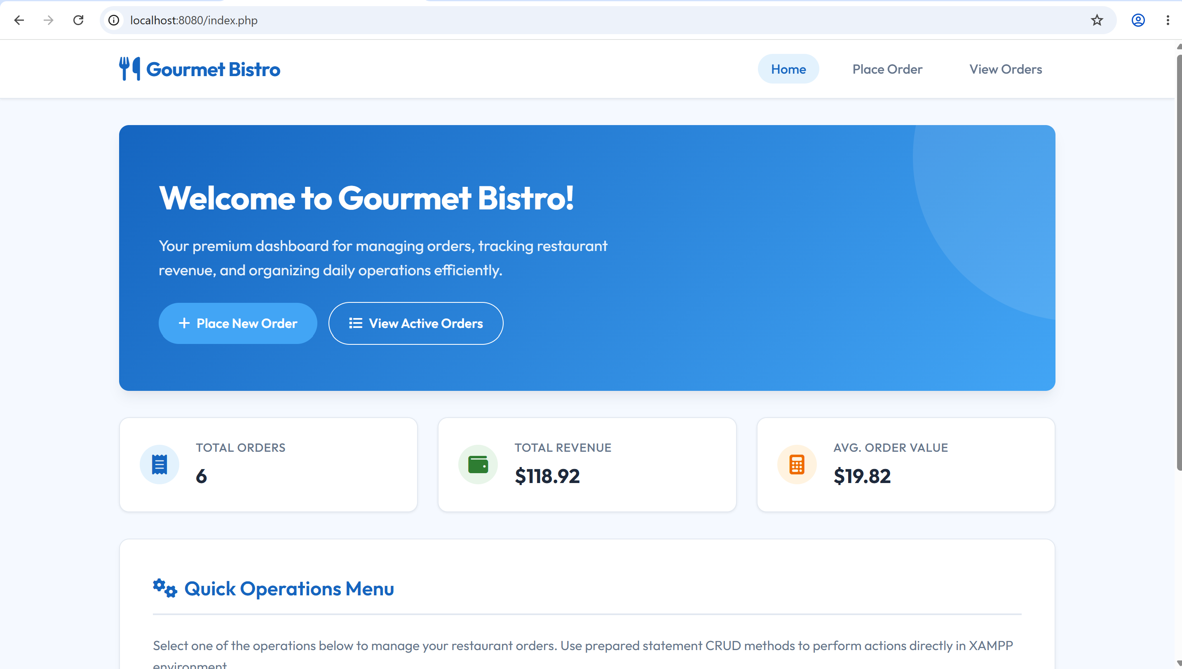
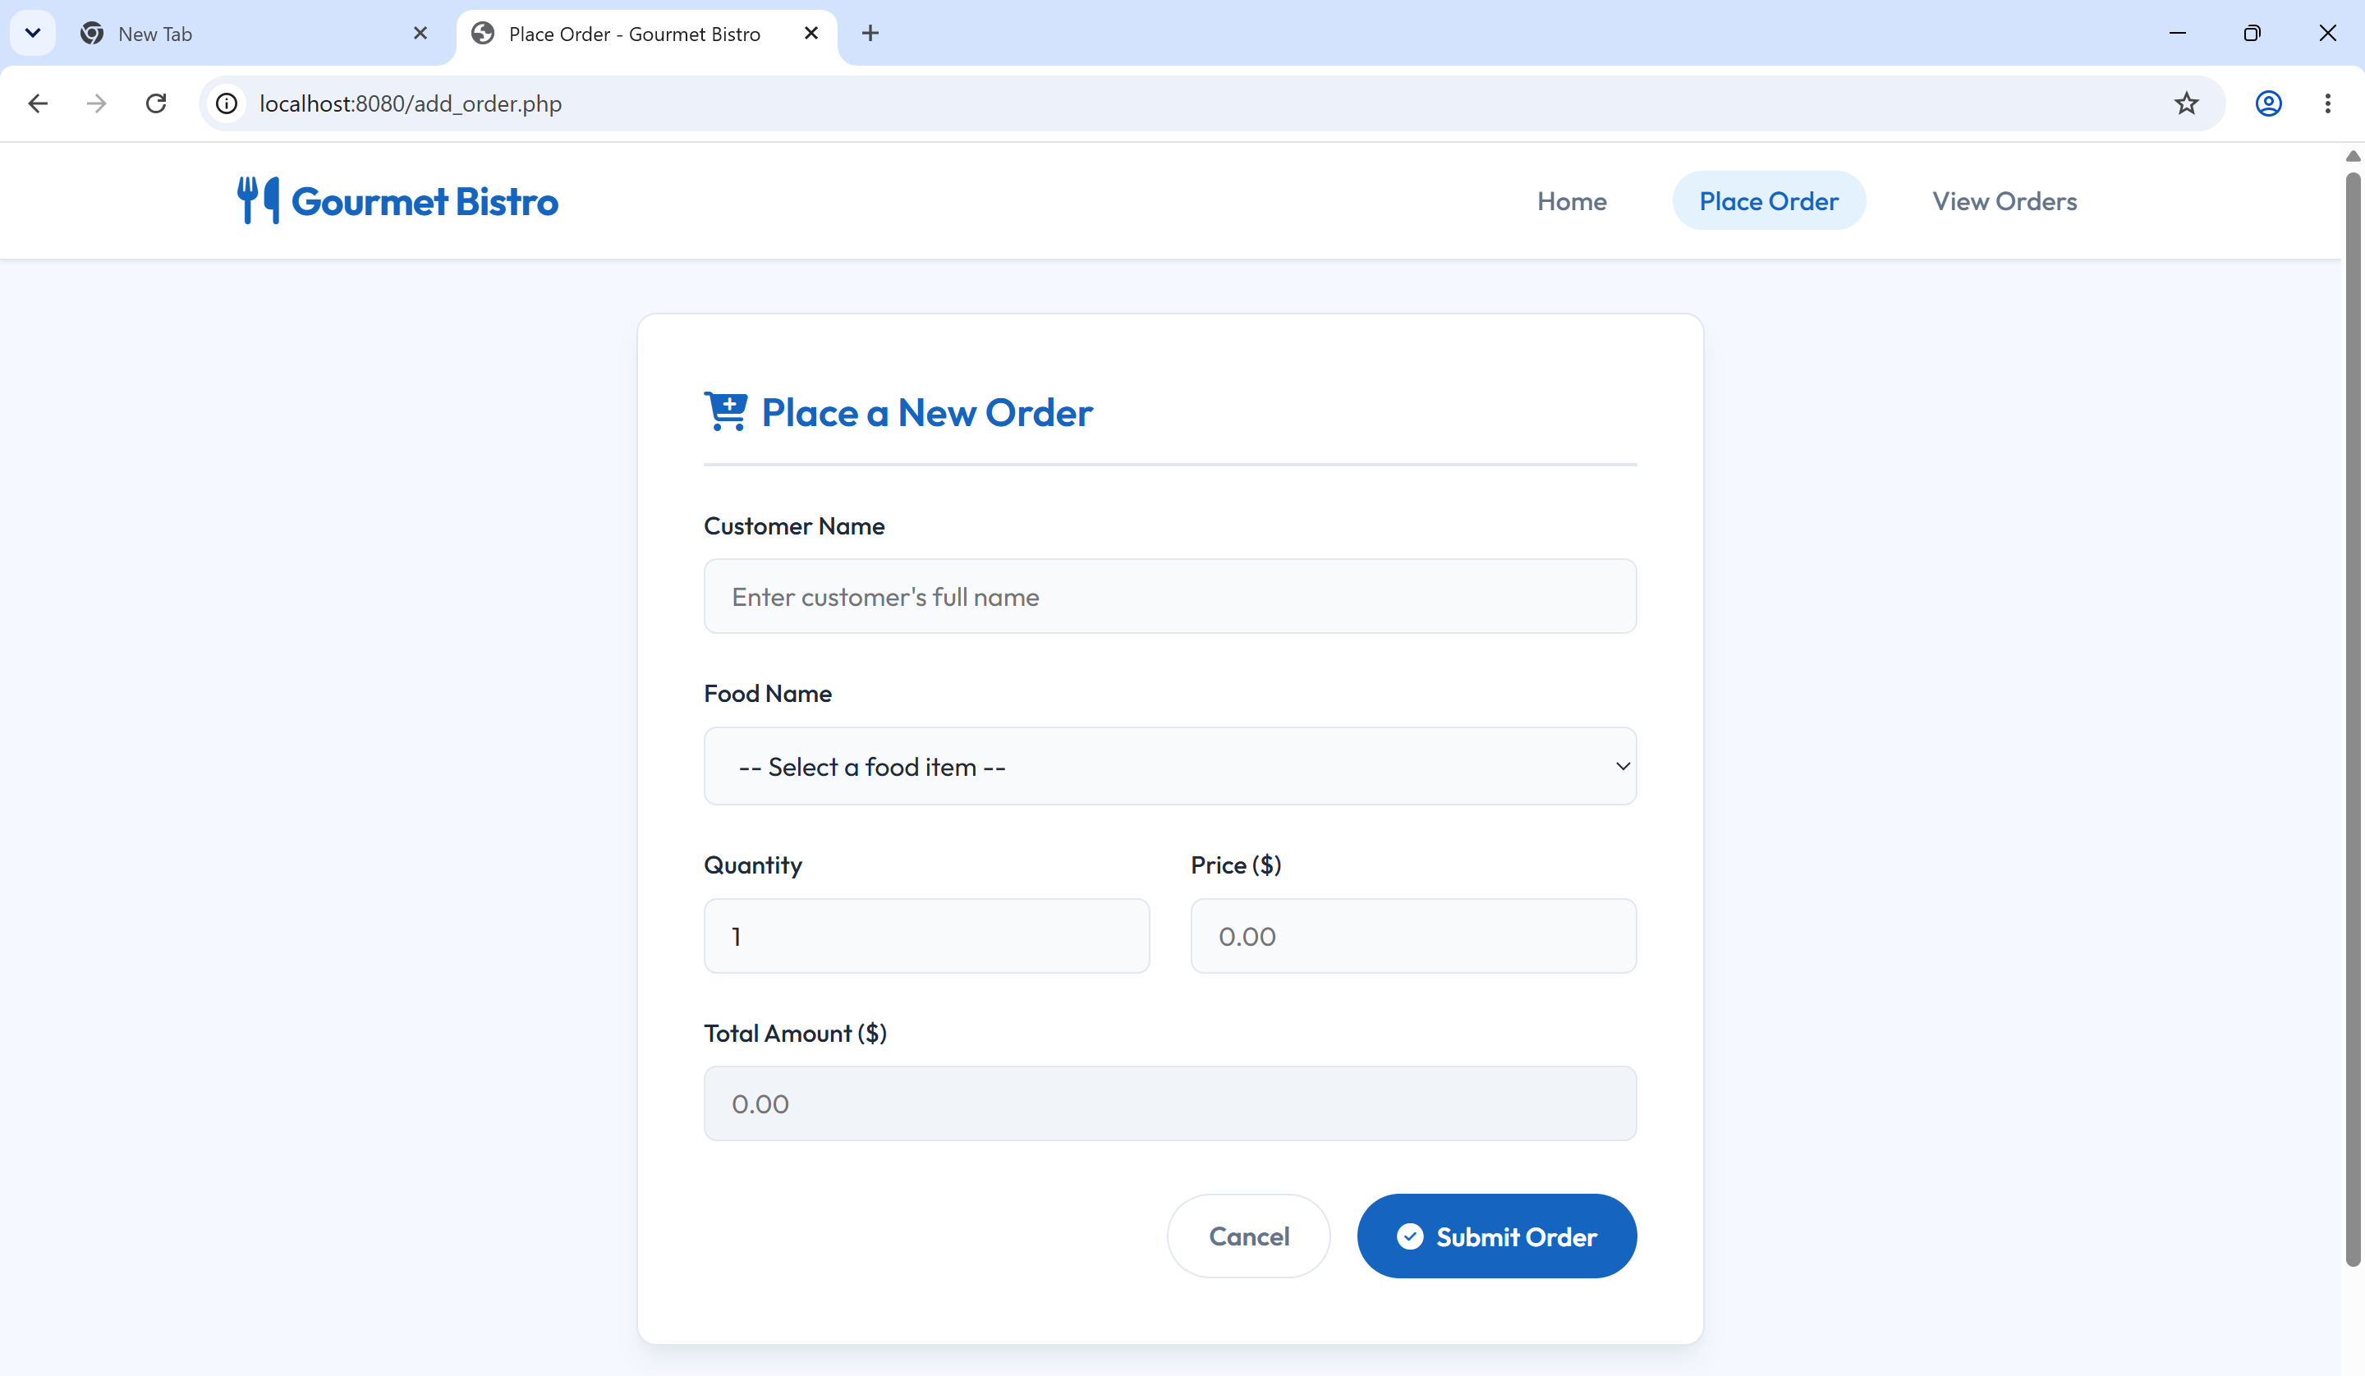
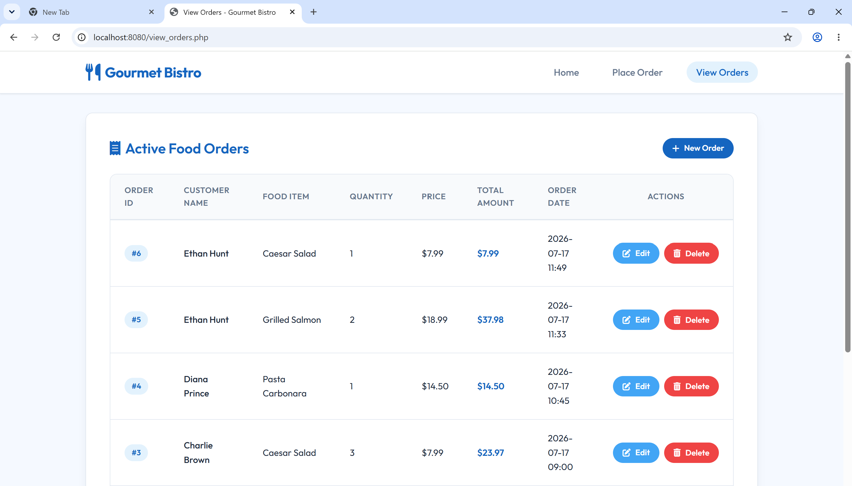
Code
<!DOCTYPE html>
<html lang="en">
<head>
<meta charset="UTF-8">
<meta name="viewport" content="width=device-width, initial-scale=1.0">
<title>View Orders - Gourmet Bistro</title>
<!-- Import stylesheet and FontAwesome for icons -->
<link rel="stylesheet" href="style.css">
<link rel="stylesheet" href="https://cdnjs.cloudflare.com/ajax/libs/font-awesome/6.4.0/css/all.min.css">
</head>
<body>

<!-- Header & Navigation Bar -->
<header>
<div class="nav-container">
<a href="index.php" class="logo-link">
<i class="fa-solid fa-utensils logo-text" style="font-size: 1.8rem; color: #1565C0;"></i>
<span class="logo-text">Gourmet Bistro</span>
</a>
<nav>
<ul>
<li><a href="index.php">Home</a></li>
<li><a href="add_order.php">Place Order</a></li>
<li><a href="view_orders.php" class="active">View Orders</a></li>
</ul>
</nav>
</div>
</header>

<!-- Main Content Area -->
<main>

<!-- Table Container Card -->
<div class="card">
<div style="display: flex; justify-content: space-between; align-items: center; margin-bottom: 1.5rem; flex-wrap: wrap; gap: 1rem;">
<h2 class="card-title" style="margin-bottom: 0; padding-bottom: 0; border-bottom: none;">
<i class="fa-solid fa-receipt"></i> Active Food Orders
</h2>
<a href="add_order.php" class="btn btn-primary btn-sm">
<i class="fa-solid fa-plus"></i> New Order
</a>
</div>

<!-- Responsive Table Wrapper -->
<div class="table-responsive">
<table>
<thead>
<tr>
<th>Order ID</th>
<th>Customer Name</th>
<th>Food Item</th>
<th>Quantity</th>
<th>Price</th>
<th>Total Amount</th>
<th>Order Date</th>
<th style="text-align: center;">Actions</th>
</tr>
</thead>
<tbody>
<!-- Order #5 -->
<tr>
<td><span class="badge badge-blue">#5</span></td>
<td style="font-weight: 500;">Ethan Hunt</td>
<td>Grilled Salmon</td>
<td>2</td>
<td>$18.99</td>
<td style="font-weight: 600; color: var(--primary-color);">$37.98</td>
<td>2026-07-17 11:33</td>
<td>
<div class="actions-cell" style="justify-content: center;">
<!-- Edit Order Link -->
<a href="edit_order.php?id=5" class="btn btn-secondary btn-sm" title="Edit Order">
<i class="fa-solid fa-pen-to-square"></i> Edit
</a>
<!-- Delete Order Link (triggers javascript confirmation prompt) -->
<button onclick="confirmDelete(5)" class="btn btn-danger btn-sm" title="Delete Order">
<i class="fa-solid fa-trash-can"></i> Delete
</button>
</div>
</td>
</tr>
<!-- Order #4 -->
<tr>
<td><span class="badge badge-blue">#4</span></td>
<td style="font-weight: 500;">Diana Prince</td>
<td>Pasta Carbonara</td>
<td>1</td>
<td>$14.50</td>
<td style="font-weight: 600; color: var(--primary-color);">$14.50</td>
<td>2026-07-17 10:45</td>
<td>
<div class="actions-cell" style="justify-content: center;">
<a href="edit_order.php?id=4" class="btn btn-secondary btn-sm" title="Edit Order">
<i class="fa-solid fa-pen-to-square"></i> Edit
</a>
<button onclick="confirmDelete(4)" class="btn btn-danger btn-sm" title="Delete Order">
<i class="fa-solid fa-trash-can"></i> Delete
</button>
</div>
</td>
</tr>
<!-- Order #3 -->
<tr>
<td><span class="badge badge-blue">#3</span></td>
<td style="font-weight: 500;">Charlie Brown</td>
<td>Caesar Salad</td>
<td>3</td>
<td>$7.99</td>
<td style="font-weight: 600; color: var(--primary-color);">$23.97</td>
<td>2026-07-17 09:00</td>
<td>
<div class="actions-cell" style="justify-content: center;">
<a href="edit_order.php?id=3" class="btn btn-secondary btn-sm" title="Edit Order">
<i class="fa-solid fa-pen-to-square"></i> Edit
</a>
<button onclick="confirmDelete(3)" class="btn btn-danger btn-sm" title="Delete Order">
<i class="fa-solid fa-trash-can"></i> Delete
</button>
</div>
</td>
</tr>
<!-- Order #2 -->
<tr>
<td><span class="badge badge-blue">#2</span></td>
<td style="font-weight: 500;">Bob Johnson</td>
<td>Cheeseburger</td>
<td>1</td>
<td>$8.50</td>
<td style="font-weight: 600; color: var(--primary-color);">$8.50</td>
<td>2026-07-16 13:15</td>
<td>
<div class="actions-cell" style="justify-content: center;">
<a href="edit_order.php?id=2" class="btn btn-secondary btn-sm" title="Edit Order">
<i class="fa-solid fa-pen-to-square"></i> Edit
</a>
<button onclick="confirmDelete(2)" class="btn btn-danger btn-sm" title="Delete Order">
<i class="fa-solid fa-trash-can"></i> Delete
</button>
</div>
</td>
</tr>
<!-- Order #1 -->
<tr>
<td><span class="badge badge-blue">#1</span></td>
<td style="font-weight: 500;">Alice Smith</td>
<td>Margherita Pizza</td>
<td>2</td>
<td>$12.99</td>
<td style="font-weight: 600; color: var(--primary-color);">$25.98</td>
<td>2026-07-15 12:30</td>
<td>
<div class="actions-cell" style="justify-content: center;">
<a href="edit_order.php?id=1" class="btn btn-secondary btn-sm" title="Edit Order">
<i class="fa-solid fa-pen-to-square"></i> Edit
</a>
<button onclick="confirmDelete(1)" class="btn btn-danger btn-sm" title="Delete Order">
<i class="fa-solid fa-trash-can"></i> Delete
</button>
</div>
</td>
</tr>
</tbody>
</table>
</div>
</div>

</main>

<!-- Footer -->
<footer>
<p>&copy; 2026 Gourmet Bistro Restaurant Management System. Built for XAMPP deployment.</p>
</footer>

<!-- Client-side dynamics & confirmation dialogs -->
<script src="script.js"></script>
</body>
</html>

